## **Objectives**

* Explain various ways of conditional rendering

Conditional rendering in React refers to the ability to render different components or elements based on a specific condition. It’s similar to conditions in JavaScript.

**Common methods:**

* If-else statements: Used when you want to return different components based on conditions.
* Ternary operator: Shorthand for if-else. condition ? true : false
* Logical && operator: Renders a component only if the condition is true.
* Switch case: Helpful for multiple condition checks.

These methods help in building dynamic and responsive interfaces based on user actions, authentication, roles, etc.

* Explain how to render multiple components

In React, you can render multiple components together within a parent component. This can be done using:

* React Fragments (<>...</>): Lightweight way to return multiple elements without adding extra nodes to the DOM.
* Arrays of JSX elements: Useful when dynamically creating elements in a loop.
* Wrapper components (like a div): Traditional way but adds an extra element in the DOM.
  + This helps in organizing UI into logical sections and reusable blocks.
* Define list component

A List Component in React is a reusable component designed to render lists of items, such as names, numbers, products, etc.

React efficiently renders lists using the map() function and key prop to identify each item uniquely. Lists are often used to display data fetched from an API.

* Explain about keys in React applications

Keys are special string attributes that help React identify which items have changed, been added, or removed.

* Keys must be unique among siblings.
* Should be assigned using unique ids or values, not indexes (if possible).
* Help React optimize re-rendering and improve performance during updates.

Using keys incorrectly can lead to unexpected UI behavior and rendering bugs.

* Explain how to extract components with keys

When extracting a list item into its own component, the key should be passed to the outer list component and not used inside the child.

Because React needs the key to be on the same level where the list is being mapped to track each component correctly.

**Best practice:** Pass the key during mapping, not inside the component itself.

* Explain React Map, map() function

The map() function in React is used to loop through arrays and return JSX elements.

* Allows dynamic rendering of list-based content.
* Each element returned from map() must have a unique key.
* Often used in rendering tables, dropdowns, checklists, etc.

It’s one of the most commonly used methods to build dynamic and scalable UI structures.

## **Notes**

Estimated time to complete this lab: **60 minutes.**

Create a React App named “bloggerapp” in with 3 components.

1. Book Details
2. Blog Details
3. Course Details

Implement this with as many ways possible of Conditional Rendering.

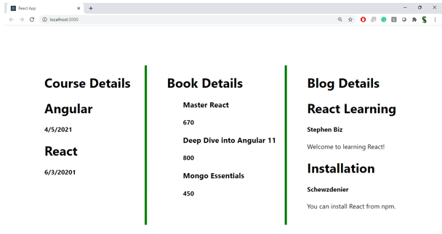

**Hint:**

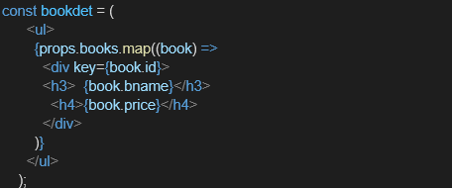

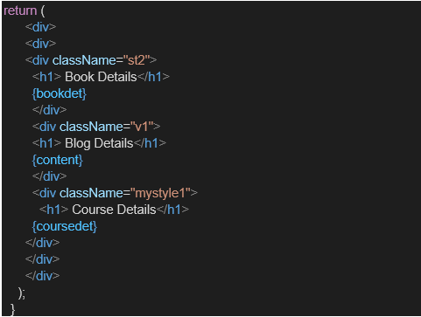

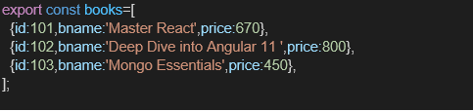

**Handson:**

